**SHRAVYA DEVATA**

**2023JULB01107**

**BIDISHA GOGOI**

**2023JULB01242**

**SHREYA PAREKH**

**2023JULB01169**

**SHRUTI JAIN**

**2023JULB01306**

**SHAKSHI CHOUDHARY 2023AUGVPGP0002**

**ANALYSING THE FINANCIAL PERFORMNACE OF TOP 12 GERMAN COMPANIES BETWEEN 2017 - 2024**

**STRATEGIC DECISIONS USING POWER BI – GROUP ASSIGNMENT**

Table of Contents

1. Business Problem 2

1.1 Objective: 2

1.2 Scope: 2

1.3 Expected Outcomes: 2

1.4 What Was Done: 2

2. Data Requirement 3

2.1 Why Do We Need It: 3

2.2 Details: 3

3. Data Collection 4

4. Data Understanding 4

4.1 ROA: 4

4.2 ROE: 4

4.3 Net Income Trends: 4

4.4 Debt-to-Equity 5

4.5 Sectoral Insights: 5

5. Data Validation 5

5.1 Validation Checks Performed: 5

5.2 How It Was Done 5

6. Visualisation tool: Power BI 6

6.1 Power BI offers: 6

6.2 How Was It Applied: 6

7. Dashboards 7

7.1 Dashboard 1 7

7.2 Dashboard 2 8

8. Charts 9

8.1 Bar Chart: Sum of ROA (%) by Company 9

8.2 Line Chart: Sum of Net Income by Year and Company 9

8.3 Clustered Bar Chart: Sum of Liabilities and Sum of Equity by Company 10

8.4 Stacked Bar Chart: Sum of Debt to Equity by Year and Company 10

8.5 Bar Chart: Sum of ROE (%) by Company 11

8.6 Doughnut Chart: Sum of ROA (%) and Sum of ROE (%) by Company 11

8.7 Bar Chart: Sum of Net Income by Year and Company (SAP SE vs. Siemens AG) 12

8.8 Line Chart: Sum of Liabilities by Year and Company (Deutsche Bank AG) 13

8.9 Clustered Bar Chart: Sum of Net Income by Year and Company (Allianz SE vs. Deutsche Bank AG) 13

8.10 Clustered Bar Chart: Sum of Net Income by Year and Company (BMW AG, Daimler AG, Porsche AG, Volkswagen AG) 14

8.11 Line Chart: Sum of Assets by Year and Company (Allianz SE) 14

8.12 Clustered Bar Chart: Sum of Net Income by Year and Company (Bayer AG vs. Merck KGaA) 15

9. Insights from the Visualization 15

# Business Problem

The business problem canters on understanding the financial performance of the top 12 German companies between 2017 and 2024. The goal is to:

* Evaluate operational efficiency through metrics like ROA (Return on Assets) and ROE (Return on Equity).
* Assess financial stability via Debt-to-Equity ratios and Liabilities vs. Equity.
* Identify trends in Net Income, which reflect profitability and growth.
* Understand sectoral strengths (e.g., automotive and pharmaceutical industries) to identify industry resilience and opportunities for investment.

## 1.1 Objective:

* To uncover financial strengths, weaknesses, and patterns among companies.

## 1.2 Scope:

* Covers 12 companies across various sectors (e.g., Volkswagen AG, Allianz SE, Bayer AG) from 2017 to 2024.

## 1.3 Expected Outcomes:

* Identify top-performing companies by key metrics.
* Reveal sector-specific growth and operational efficiency.

## 1.4 What Was Done:

* The financial performance metrics were chosen as benchmarks for the analysis. Each company’s performance was studied across time, enabling comparison of financial health and trends.
* Identified key performance indicators (KPIs) like ROA, ROE, Net Income, Debt-to-Equity, and Liabilities vs. Equity.
* Categorized companies by industry (e.g., automotive, pharmaceutical) to explore sector-specific trends.

# Data Requirement

## 2.1 Why Do We Need It:

Identifying and defining the required data ensures the analysis focuses on relevant metrics. For financial performance analysis, essential data requirements include:

* **ROA:** Indicates how well a company uses its assets to generate profits.
* **ROE:** Measures profitability relative to shareholders’ equity.
* **Net Income:** Tracks the profitability of the companies over time.
* **Debt-to-Equity Ratio:** Represents the degree of financial leverage used.
* **Liabilities and Equity:** Shows the company’s financial structure and risk exposure.

## 2.2 Details:

* **Primary Data:** Financial statements and ratios for 12 companies from 2017–2024.
* **Metrics Breakdown:**
* Operational Efficiency: ROA and ROE.
* Financial Stability: Debt-to-Equity and Liabilities vs. Equity.
* Profitability: Net Income trends over time.

The metrics were chosen to cover operational, financial, and structural aspects of performance. These were linked to business objectives such as efficiency, leverage management, and profitability tracking.

# Data Collection

Data collection is critical to ensuring the reliability and validity of the analysis. Without accurate and complete data, conclusions could be misleading.

**Details**

* **Source:** The financial data was gathered from company annual reports, market databases, and verified public sources.
* **Data Period:** Spanning 2017 to 2024, capturing both historical trends and recent performance.
* **Companies Covered:**
* **Automotive:** Volkswagen AG, Daimler AG, BMW AG.
* **Financials:** Allianz SE, Deutsche Bank AG.
* **Pharmaceuticals:** Bayer AG, Merck KGaA.

The data was likely extracted from company reports, financial databases, and market research for top German firms. The raw data was compiled into an Excel sheet, ensuring a structured format suitable for analysis. Cleaning processes were applied to remove redundancies, correct errors, and ensure data readiness.

# Data Understanding

Data understanding provides context and ensures the analysis aligns with real-world scenarios. It enables meaningful interpretation of trends and outliers.

## 4.1 ROA:

* Volkswagen AG leads with 85.65%, showcasing high asset efficiency.

## 4.2 ROE:

* Daimler AG and Volkswagen AG demonstrate strong equity returns (180.57% and 180.21%, respectively).

## 4.3 Net Income Trends:

* Allianz SE and Deutsche Bank AG show steady growth.
* Merck KGaA exhibits a significant surge by 2024.

4.4 Debt-to-Equity**:**

* Balanced ratios observed in Daimler AG and Merck KGaA, signalling robust financial management.

## 4.5 Sectoral Insights:

* The automotive sector demonstrated resilience despite economic challenges.
* Pharmaceuticals showed diverse trends, reflecting varied operational efficiency.

Interactive dashboards in Power BI allowed for slicing and dicing data by time, company, and sector. This visual approach highlighted key trends and industry-wide patterns.

# Data Validation

Data validation ensures the accuracy, completeness, and reliability of the dataset. Without validation, the results of the analysis might be flawed.

## 5.1 Validation Checks Performed:

* **Data Consistency:** Ensuring financial metrics align with industry norms.
* **Anomaly Detection:** Identifying and addressing fluctuations or discrepancies in the data.
* **Cross-Verification:** Comparing metrics against external financial databases or company reports.

## 5.2 How It Was Done

* **Cleaning:** The Excel sheet was processed to remove duplicates, fix errors, and fill missing values.
* **Power BI Calculations:** Ratios and metrics were recalculated within Power BI to confirm accuracy.
* **Iterative Validation:** Continuous checks were performed to ensure the dashboard reflected accurate and reliable insights.

# Visualisation tool: Power BI

## 6.1 Power BI offers:

* Dynamic dashboards for exploring trends across companies and metrics.
* Enhanced visuals like bar charts, line graphs, and slicers for comparative and time-series analyses.
* Tools to segment performance by industry or company efficiently.

## 6.2 How Was It Applied:

The financial metrics were visualized using dashboards to:

* Highlight top-performing companies.
* Display industry trends and year-over-year growth patterns.
* Provide a holistic view of liabilities, equity, and net income changes across years.

# Dashboards

## 7.1 Dashboard 1

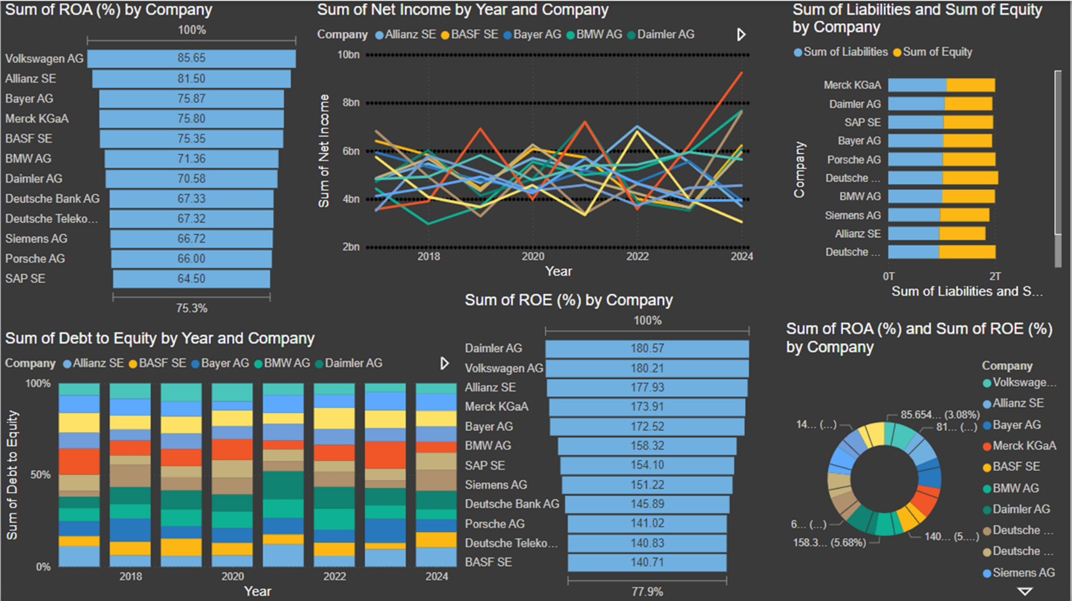

## 7.2 Dashboard 2

# Charts

## 8.1 Bar Chart: Sum of ROA (%) by Company

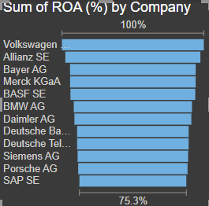

* **Purpose:** The bar chart effectively compares the Return on Assets (ROA) across different companies. The horizontal bars provide a clear and straightforward view of ranking.
* **Chart Type Justification:** Bar charts are ideal for comparing discrete categories, and in this case, the comparison of ROA values for different companies is achieved clearly.
* **Type of Data**: Univariate, as it analyzes a single variable (ROA) across multiple companies.

## 8.2 Line Chart: Sum of Net Income by Year and Company

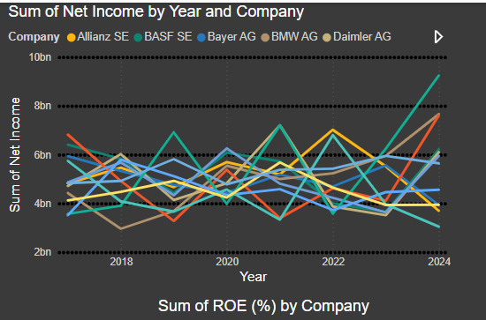

* **Purpose:** The line chart illustrates trends in net income over time for multiple companies, allowing viewers to analyze both year-on-year changes and company-specific performance.
* **Chart Type Justification:** Line charts are well-suited for displaying trends over time, and the use of multiple lines enables effective comparison between companies.
* **Type of Data:** Multivariate, as it involves three variables: year (x-axis), net income (y-axis), and company (categories).

## 8.3 Clustered Bar Chart: Sum of Liabilities and Sum of Equity by Company

* **Purpose:** This chart shows the composition of liabilities and equity for each company, helping to analyze their financial structure.
* **Chart Type Justification:** Clustered bar charts are effective for displaying two related data points (liabilities and equity) for comparison across categories (companies).
* **Type of Data:** Bivariate, as it compares two variables (liabilities and equity) across multiple companies.

## 8.4 Stacked Bar Chart: Sum of Debt to Equity by Year and Company

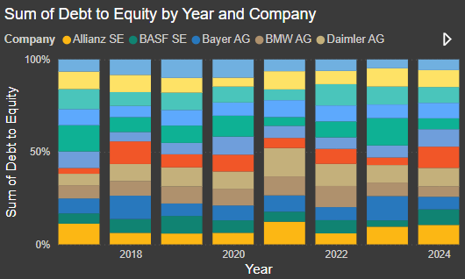

* **Purpose:** The stacked bar chart illustrates the proportion of debt to equity over the years for different companies, showing both total and relative contributions.
* **Chart Type Justification:** Stacked bar charts are ideal for displaying parts of a whole across multiple categories and time periods.
* **Type of Data:** Multivariate, as it incorporates year (x-axis), company (categories), and debt-to-equity ratio (stacked proportions).

## 8.5 Bar Chart: Sum of ROE (%) by Company

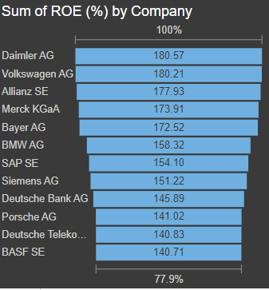

* **Purpose:** Like the ROA chart, this bar chart compares Return on Equity (ROE) across different companies, ranking them based on performance.
* **Chart Type Justification:** Bar charts provide a clear and concise way to visualize ranking and magnitude for a single variable across categories.
* **Type of Data:** Univariate, as it focuses on a single variable (ROE) across companies.

## 8.6 Doughnut Chart: Sum of ROA (%) and Sum of ROE (%) by Company

* **Purpose:** The doughnut chart provides a proportional breakdown of ROA and ROE across companies, showing their relative contributions.
* **Chart Type Justification:** Doughnut charts are useful for visualizing proportions within a dataset. Here, it highlights the share of ROA and ROE for each company.
* **Type of Data:** Bivariate, as it combines two variables (ROA and ROE) into a proportional view.

## 8.7 Bar Chart: Sum of Net Income by Year and Company (SAP SE vs. Siemens AG)

* **Purpose:** This chart compares the net income of SAP SE and Siemens AG over multiple years.
* **Chart Type Justification:** A clustered bar chart is ideal for comparing two companies' net incomes across discrete years, enabling side-by-side analysis.
* **Type of Data:** Bivariate, as it involves two variables—net income and year—broken down by company.

## 8.8 Line Chart: Sum of Liabilities by Year and Company (Deutsche Bank AG)

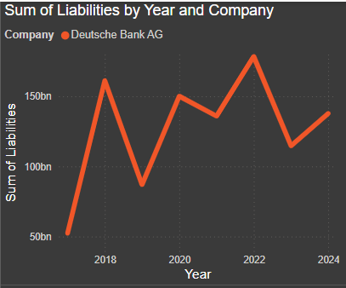

* **Purpose:** The line chart shows how liabilities have changed for Deutsche Bank AG over time.
* **Chart Type Justification:** A line chart is appropriate for analyzing trends over time, providing a clear picture of changes in liabilities across years.
* **Type of Data:** Bivariate, as it examines the relationship between two variables—year and liabilities.

## 8.9 Clustered Bar Chart: Sum of Net Income by Year and Company (Allianz SE vs. Deutsche Bank AG)

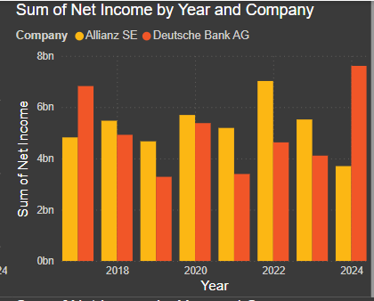

* **Purpose:** This chart compares the net income of Allianz SE and Deutsche Bank AG over multiple years.
* **Chart Type Justification:** Clustered bar charts work well for side-by-side comparisons of performance across years.
* **Type of Data:** Bivariate, as it focuses on net income over time for two companies.

## 8.10 Clustered Bar Chart: Sum of Net Income by Year and Company (BMW AG, Daimler AG, Porsche AG, Volkswagen AG)

* **Purpose:** The chart compares net income for four companies over time.
* **Chart Type Justification:** Clustered bar charts are effective for comparing multiple categories (companies) across time periods.
* **Type of Data:** Multivariate, as it involves year, net income, and multiple companies.

## 8.11 Line Chart: Sum of Assets by Year and Company (Allianz SE)

* **Purpose:** The line chart illustrates the trend in Allianz SE’s assets over time.
* **Chart Type Justification:** A line chart is suitable for tracking changes in a single variable (assets) over time.
* **Type of Data**: Bivariate, as it shows the relationship between time (years) and the sum of assets.

## 8.12 Clustered Bar Chart: Sum of Net Income by Year and Company (Bayer AG vs. Merck KGaA)

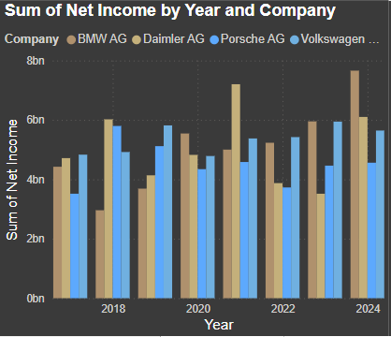

* **Purpose:** This chart compares the net income of Bayer AG and Merck KGaA over the years.
* **Chart Type Justification:** Clustered bar charts effectively compare performance between two companies over time.
* **Type of Data:** Bivariate, as it focuses on two variables—net income and year—broken down by company.

# Insights from the Visualization

* 1. **Top ROA Performers**:  
     Volkswagen AG leads in ROA (85.65%), showcasing efficient asset utilization. Allianz SE and Bayer AG also perform strongly, indicating good operational efficiency.
  2. **ROE Leaders**:  
     Daimler AG and Volkswagen AG exhibit the highest ROE (180.57% and 180.21%, respectively), demonstrating effective shareholder fund utilization.
  3. **Leverage Overview**:  
     Debt-to-equity ratios are consistent across companies, but firms like Daimler AG and Merck KGaA demonstrate balanced liabilities relative to equity, signaling robust financial management.
  4. **Net Income Trends**:  
     Net income shows variability across years for all companies, with steady growth visible for certain firms like Allianz SE and Bayer AG.
  5. **Liabilities vs. Equity**:  
     Companies like Merck KGaA and Daimler AG maintain relatively higher equity proportions, suggesting lower risk from excessive leverage.
  6. **Allianz SE** and **Deutsche Bank AG** show steady growth in net income, with Allianz SE achieving consistent performance.
  7. **BMW AG**, **Daimler AG**, and **Volkswagen AG** exhibit growth in net income, with Volkswagen AG outperforming in recent years.
  8. **Bayer AG** and **Merck KGaA** show contrasting net income trends, with Merck KGaA achieving a significant surge by 2024.
  9. **Deutsche Bank AG** has fluctuating liabilities, indicating potential financial restructuring efforts.
  10. **Allianz SE** demonstrates steady growth in assets, reflecting a robust and expanding financial base.
  11. **The automotive sector** (Volkswagen AG, Daimler AG) shows resilience in net income despite economic challenges.
  12. **Pharmaceutical companies** (Bayer AG, Merck KGaA) display diverse trends, signaling varying operational efficiency.

**THANK YOU**